

Mortgage Permission - User Stories & Wireframes

Contents
User Stories- Mortgage Permission Process 2
1. User Story- Add Mortgage Request 2
1.1 Mock-ups 5
2. User Story- Approve/Reject Mortgage Request 8
2.1 Mock-ups 9
3. User Story- View Request- Department User 12
3.1 Mock-ups 13
4. User Story- View Request- Approver 15
4.1 Mock-ups 16
5. User Story- Resubmit request for mortgage request 18
5.1 Mock-ups 19
6. User Story- Cancel mortgage request 21
6.1 Mock-ups 22
7. User Story- View Comment 23
7.1 Mock-ups 24
8. User Story- Generate Mortgage Letter 26
8.1 Mock-ups 27
9. User Story- SMS/Email Notifications to allottee 28

User Stories- Mortgage Permission Process

User Story- Add Mortgage Request

Sprint | 4
User Story ID | 001
User Story Title | Add Mortgage Request
Actors | Department user
Story | As an assistant, I want to request for mortgage permission of property to manager level, so that I can generate mortgage letter.
Pre Conditions | - User should have required access rights.
Business Criteria | - Unique Request no. would be generated for each mortgage request.  - Once, the request is submitted a notification would be sent to approver for the same.  - Auto notifications will be sent to approver with an interval of 3 days, if a request is in progress for approval for more than 3 days.  - An Email/SMS notification would be sent to allottee along with the request no.  - If a request is submitted to an approver but not actioned its status would be ‘In progress’. Approved and rejected requests would have ‘approved’ and ‘rejected’ status respectively.  - If the request is cancelled by the department user, its status would be ‘cancelled’.  - The request will only be approved if the property is functional and there are no dues against it.  - Mortgage permission can only be requested either before the lease deed execution or after lease deed execution.  - For the purpose of granting collateral security, processing fee would be charged as per the rule.
Acceptance Criteria | - User would click on ‘Add Mortgage Request’ option under Manage Mortgage menu and get a form which contain following fields:  - RID: drop down, mandatory  - Allottee Name: Label  - Father Name: Label  - Department: Label  - Property Type: label  - Property Number: Label  - Property Cost: Label  - Total Dues: Label  - Functional: Label  - Request Date: Date picker, mandatory  - Approval Date: Label (Once the request is approved, date would be reflected)  - Mortgage Bank Name: Text Box, mandatory  - Branch Address: Text Area, mandatory  - Mortgage Type: Dropdown, mandatory  - Processing Fee: Text Box, mandatory  - Valid Up to: Date picker, mandatory  - Previous Mortgage Bank Details: label  - Previous Loan Bank NOC: Dropdown, mandatory  - Once, user validates the information he would submit request for mortgage to manager level by clicking on ‘Submit Request for Approval’ button. User would get a popup to select approver name, user would select desired name and click on ‘Submit’ button.  - Alternatively, user would click on ‘Back’ button to return to mortgage menu without making any changes.  - After successful submission of request, it would be displayed in a grid on manage mortgage page with following columns:  - Request No  - RID  - Scheme  - Department  - Status (in progress, cancelled, approved, reject)  - Request Date  - Applicant Name  - Mortgage Purpose  - The options available in “Mortgage Purpose” dropdown are:  - Normal  - Collateral
Field level Validation | - Mortgage Bank Name: Text, maximum 100 characters  - Branch Address: Text, maximum 500 characters  - Processing fee: Numeric, Decimal (15,2)

Mock-ups

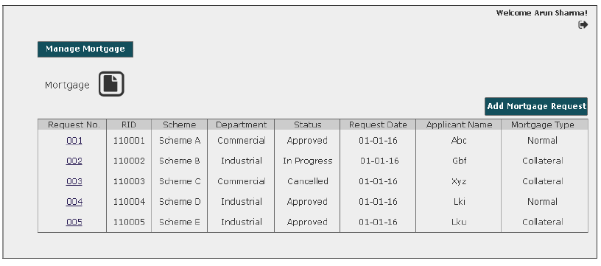

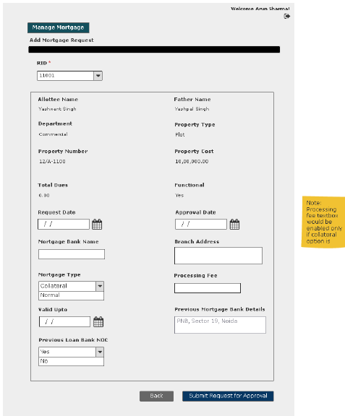

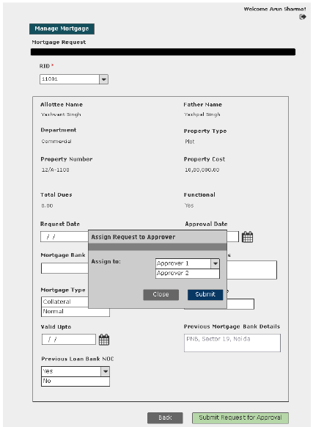

User Story- Approve/Reject Mortgage Request

Sprint | 4
User Story ID | 001
User Story Title | Approve/Reject mortgage request
Actors | Approver
Story | As an assistant, I want to action mortgage request of a property so that I can Approve/Reject request
Pre Conditions | - User should have required access rights.
Business Criteria | - Once a request is approved/rejected a notification would be send to initiator of the request.  - It is mandatory to provide a comment for rejecting a request.  - If a request is not actioned its status would be ‘No action’. Approved and rejected requests would have ‘approved’ and ‘rejected’ status respectively.  - If the request is cancelled by the department user, its status would be ‘cancelled’. Approver would not get any options to approve, reject.  - The request will only be approved if the property is functional and there are no due against it.  - Mortgage permission can only be requested either before the lease deed execution or after lease deed execution.  - For the purpose of granting collateral security, processing fee would be charged as per the rule.
Acceptance Criteria | - User would click on ‘Mortgage Request’ option under ‘Manage Request’ menu and get a grid which contain mortgage request information with following columns:  - Request No  - RID  - Scheme  - Department  - Status (in progress, cancelled, approved, reject)  - Request Date  - Applicant Name  - Mortgage Purpose  - User would click on the request to approve/reject and based on this selection the following information would be displayed:  - RID: drop down, mandatory  - Allottee Name  - Father Name  - Department  - Property Type  - Property Number  - Property Cost  - Total Dues  - Functional  - Request Date  - Approval Date  - Mortgage Bank Name  - Branch Address  - Mortgage Type  - Processing Fee  - Valid Up to  - Previous Mortgage Bank Details  - Previous Loan Bank NOC  - If user finds that the property is functional and there are no pending dues against the property. Then, user would click on ‘Approve’ button to approve the request. Alternatively, would click on ‘Reject’ button to reject the request if conditions are not fulfilled.  - In both cases user would get a popup window to provide comment.  - In case of ‘Approve’ user would have a choice to provide comment or not however, in case of ‘Reject’ it is mandatory to provide comment.
Field level Validation

2.1 Mock-ups

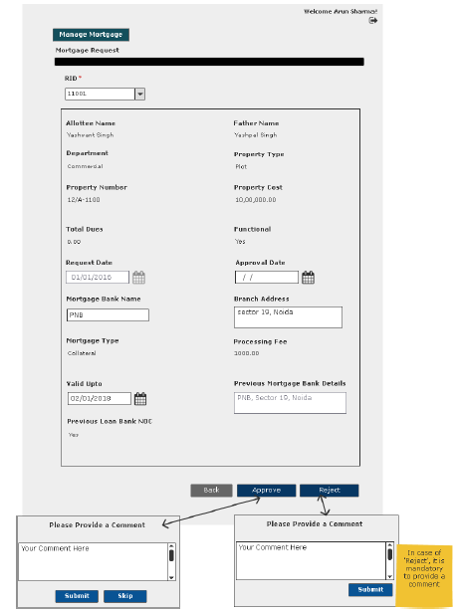

User Story- View Request- Department User

Sprint | 4
User Story ID | 003
User Story Title | View Request
Actors | Department User
Story | As an assistant, I want to view submitted mortgage request of a property.
Pre Conditions | - User should have required access rights.
Business Criteria | - If request is submitted but not actioned by the approver, then user would get ‘Cancel Request’ option only.  - If the request is rejected by the approver, then user would get the option of ‘Resubmit Request’ and ‘View Comment’.  - For cancelled requests user would get the option to ‘resubmit Request’  - If request is approved by the approver, then user would get following options:  - Generate Mortgage Letter  - View Comment
Acceptance Criteria | - User would click on a particular request from the grid under manage mortgage menu.  - User would get a screen which would display the following information:  - RID: drop down, mandatory  - Allottee Name  - Father Name  - Department  - Property Type  - Property Number  - Property Cost  - Total Dues  - Functional  - Request Date  - Approval Date  - Mortgage Bank Name  - Branch Address  - Mortgage Type  - Processing Fee  - Valid Up to  - Previous Mortgage Bank Details  - Previous Loan Bank NOC
Field level Validation

Mock-ups

The cases covered in the Business Rules in context to “Status” are shown in the wireframe. Please refer.
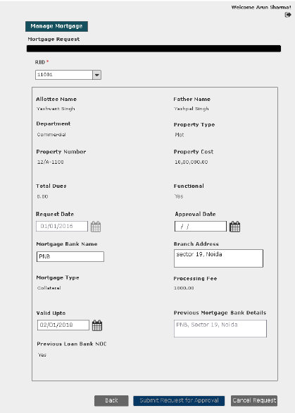
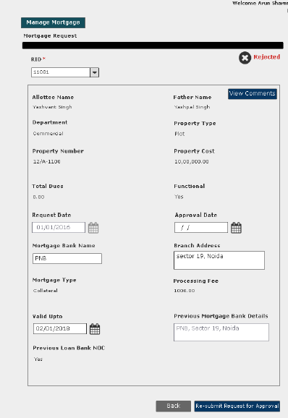
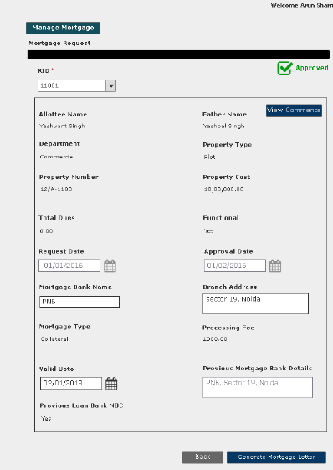

User Story- View Request- Approver

Sprint | 4
User Story ID | 004
User Story Title | View Request
Actors | Approver
Story | As an Approver, I want to view submitted mortgage request of a property.
Pre Conditions | - User should have required access rights.
Business Criteria | - If the request is not actioned then, user would get ‘Approve’ and ‘Reject’ button.  - If request is cancelled, approved or rejected then user would not get any option.
Acceptance Criteria | - User would click on approved service request number from the grid under Manage Request menu  - User would get a screen which would display the following information:  - RID: drop down, mandatory  - Allottee Name  - Father Name  - Department  - Property Type  - Property Number  - Property Cost  - Total Dues  - Functional  - Request Date  - Approval Date  - Mortgage Bank Name  - Branch Address  - Mortgage Type  - Processing Fee  - Valid Up to  - Previous Mortgage Bank Details  - Previous Loan Bank NOC  - If the request is approved, then it would also contain the “Back” Button.
Field level Validation

Mock-ups

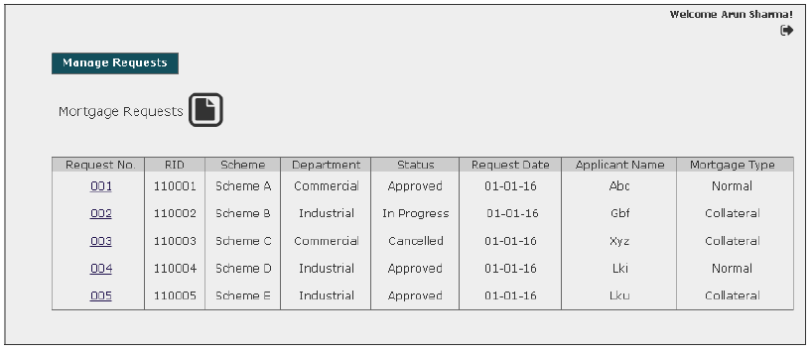
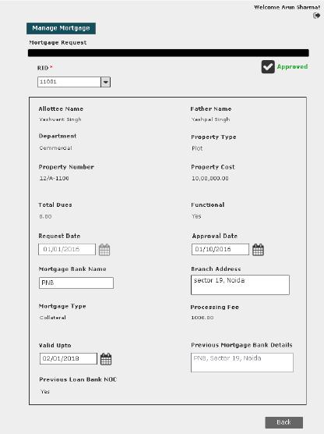

User Story- Resubmit request for mortgage request

Sprint | 4
User Story ID | 005
User Story Title | Resubmit request for mortgage permission
Actors | Department User
Story | As an assistant, I want to resubmit mortgage request of a property.
Pre Conditions | - User should have required access rights.
Business Criteria | - Only Cancelled and rejected requests would be resubmitted.  - Requested date would be updated on the grid.
Acceptance Criteria | - User would click on a particular request from the grid under manage mortgage menu.  - Request will be displayed and user would click on the ‘Resubmit’ button to request again.  - Alternatively, user would click on ‘Back’ button to return to the manage mortgage page without making any changes.
Field level Validation

Mock-ups

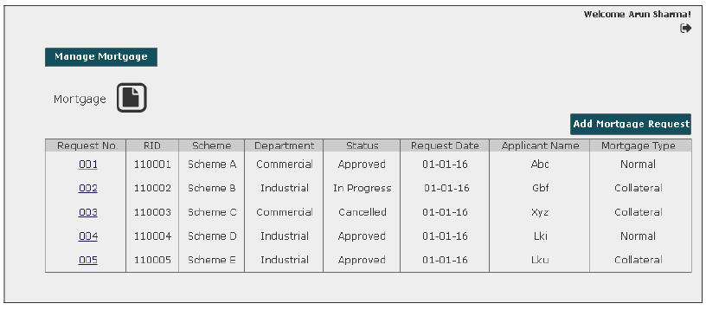

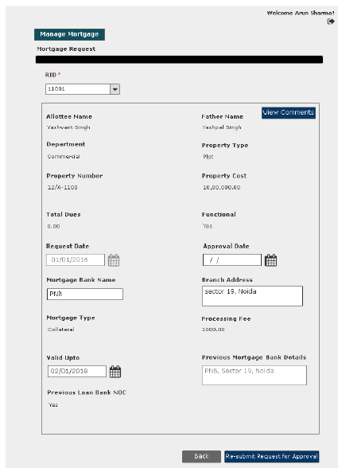

User Story- Cancel mortgage request

Sprint | 4
User Story ID | 006
User Story Title | Cancel mortgage request
Actors | Department User
Story | As an assistant, I want to cancel mortgage request of a property.
Pre Conditions | - User should have required access rights.
Business Criteria | - Only those request which are in progress would be cancelled.  - The status in the manage mortgage grid would be displayed as “Cancelled”.
Acceptance Criteria | - User would click on a particular request with status “In Progress” from the grid under manage mortgage menu.  - Request will be displayed and user would click on the ‘Cancel Request’ button to cancel the request.  - Alternatively, user would click on ‘Back’ button to return to the manage mortgage page without making any changes.
Field level Validation

Mock-ups

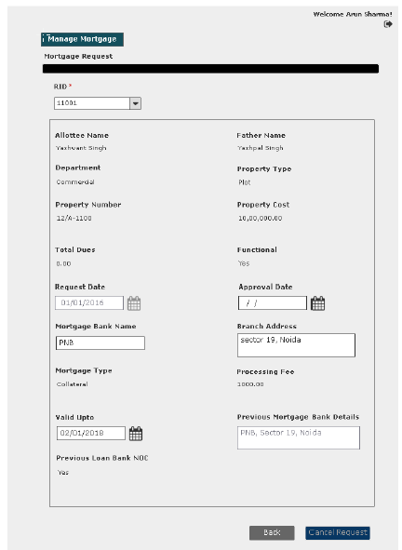

User Story- View Comment (Requestor)

Sprint | 4
User Story ID | 007
User Story Title | View Comment
Actors | Department user
Story | As an assistant, I want to view comment on Approve/Rejected mortgage request
Pre Conditions | - User should have required access rights.
Business Criteria | - Only, approved/rejected request would contain the option to View comment.
Acceptance Criteria | - User would click on ‘View Comment’ button on approved/rejected mortgage request screen.  - User would see a Popup window with the following information:  - Comment from  - Comment  - Comment Date  - If user wishes to go back or close this screen, user would click on ‘Back’ button and would be redirected to manage mortgage screen.

Mock-ups

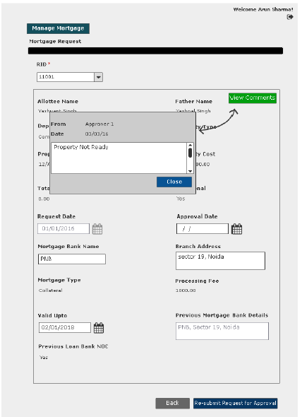

User Story- View Comment (Approver)

Sprint | 4
User Story ID | 007
User Story Title | View Comment
Actors | Approver
Story | As an approver, I want to view comment on Approve/Rejected mortgage request
Pre Conditions | - User should have required access rights.
Business Criteria | - Only, approved/rejected request would contain the option to View comment.
Acceptance Criteria | - User would click on ‘View Comment’ button on approved/rejected mortgage request screen.  - User would see a Popup window with the following information:  - Comment from  - Comment  - Comment Date  - If user wishes to go back or close this screen, user would click on ‘Back’ button and would be redirected to manage mortgage screen.

Mock-ups
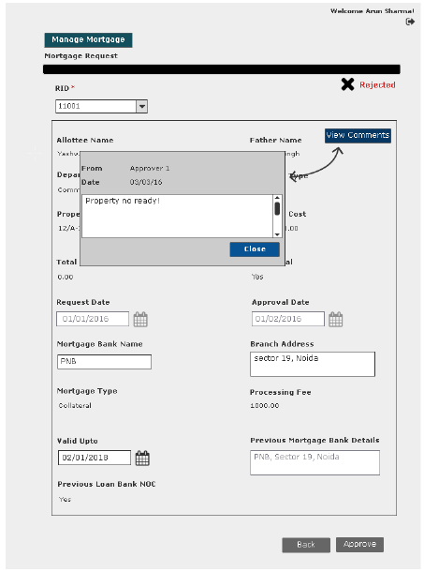

User Story- Generate Mortgage Letter

Sprint | 4
User Story ID | 008
User Story Title | Generate Mortgage Letter
Actors | Department user
Story | As an assistant, I want to generate mortgage letter.
Pre Conditions | - User should have required access rights.
Business Criteria | - Only, approved request would contain the option to generate mortgage letter.  - System would check for payment of processing fee in case of collateral mortgage. If not payed then, mortgage letter will not be generated and system would ask the user to pay the charge.
Acceptance Criteria | - User would click on ‘Generate Mortgage’ button on mortgage request screen.  - Mortgage letter would be displayed on a separate screen.  - User would have the options to save the file to his local system by clicking on ‘Download’ button or print mortgage letter by clicking on ‘Print’ button.
Field Level Validations

Mock-ups
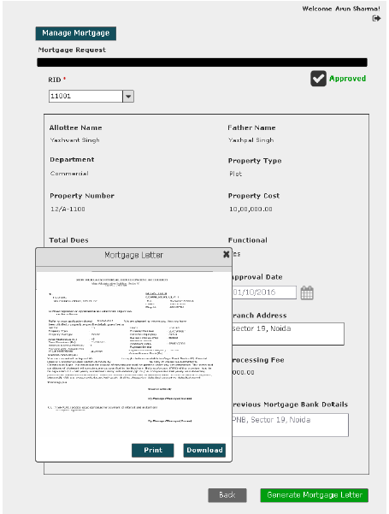

User Story- SMS/Email Notifications to allottee

Sprint | 4
User Story ID | 011
User Story Title | SMS/Email notifications to allottee
Actors | allottee
Story | As an allottee I want system to send me SMS/email notifications for mortgage request
Pre Conditions | - User should have required access rights.
Business Criteria | - An SMS/Email notification would be send to allottee once; the request is submitted for mortgage.  - An SMS/Email notification would be send to allottee once; the request is cancelled.  - An SMS/Email notification would be send to allottee once; the request is rejected with comment.  - An SMS/Email notification would be send to allottee once, the request is approved
Acceptance Criteria
Field Level Validations

